Name:_________________________

**Using the Touch Button and Sounds - MakeCode**

**What you need:**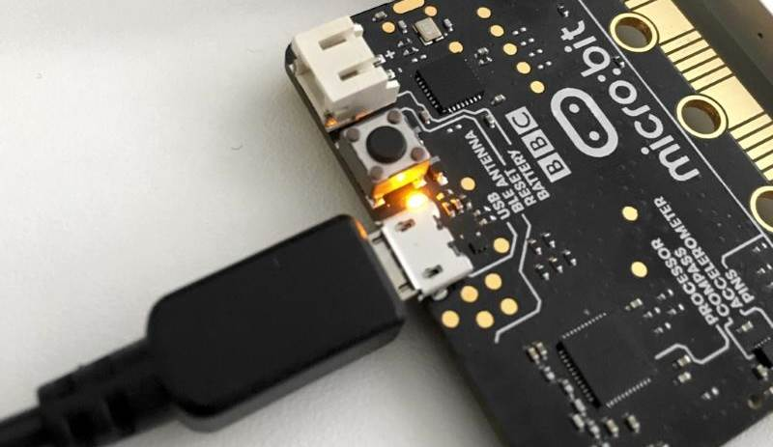

1. A computer with a USB port
2. V2.0 micro:bit
3. USB cable

**Setup:**

1. Plug in your micro:bit with the USB cable. The small USB mircoB end goes to the micro:bit and the regular USB end goes to the computer.
2. In a browser, go to <https://makecode.microbit.org/>. This is where you will program your micro:bit.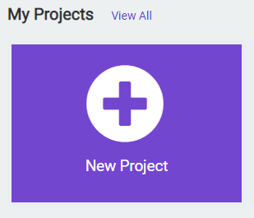
3. Click on ‘New Project’
4. You can name your project whatever you want, but you should name it based on the title of the lab. In this case, ‘Touch Button and Sounds’

**Instructions:**

1. Inside the **forever** code block, we will use the **if** block from the **Logic** tab. This code block will execute whatever code is inside it when the statement we give it becomes true.

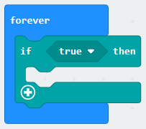

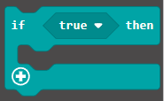

1. Inside the **if** code block, we need to change the condition of when the if statement becomes true. We will change it to when the micro:bit detects when the touch sensor is pressed on the micro:bit logo. Drag the **logo is pressed** logic block from the **Input** tab, inside of the **if** code block where it currently says **true:**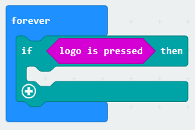



1. To have the micro:bit say something when we press the touch sensor, we need to place a **play sound** code block from the **Music** tab, like the one we used in the beginner projects. Drag it into the **if** code block. You can pick whatever sound you want from the dropdown on the code block. In this case **giggle** was the sound used.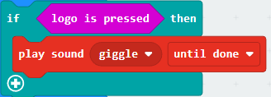



1. Click the **Download** button on the bottom on the bottom left hand side of the screen. This will upload your program to the micro:bit. Touch the micro:bit logo on the top of the micro:bit. When you press it, does the sound you chose play?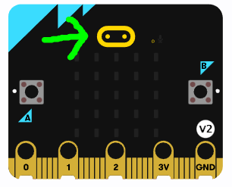

**You Try It!**

Can you make it play more than one sound when the sensor is touched?